**Safety, Health and Environment**

**Management Plan**

# Section 1, Introduction:

The company is committed to protect the safety and health of our employees and contractors, and the communities in which we operate. This Health and Safety Management Plan aims to implement the policies and approaches outlined in the Environmental Management System.

The company has a S.H.E. Policy and a Code of Ethics that provide the framework for the EMS.

These documents are posted on the company’s website. The company`s Health and Safety Management Plan (H&SMP) is based on the principle of continuous improvement, and is consistent with the Occupational Health and Safety Management System (OHSAS) 18001, and complies with all requirements of the Ontario Occupational Health and Safety Act (OHSA), and is in place to control health and safety risks ofcompany activities.

**This plan contains the following elements:**

• Policy;

• Legal Requirements;

• Hazard identification and Risk Assessment;

• Health and Safety Targets and Objectives;

• Roles and Responsibilities;

• Training and Awareness;

• Reporting and Documentation;

• S.H.E. Communication;

• Operational Control;

• Emergency Preparedness and Response;

• Performance Measurement and Monitoring;

• Accidents, Incidents, Non-Conformance, and Corrective/Preventive Actions;

• Records and Records Management;

• Audits and Assurance; and

• Management Review.

# Section2, policy.

## 2.1 Policy:

•Ensure that management accepts full responsibility for protecting workers and the environment.

•Give health, safety and environmental considerations equal status with the Company’s other business objectives and integrate them into all aspects of our work.

•Work actively to continuously improve health, safety and environmental performance.

•Only start work after confirming that essential health, safety and environmental protection systems are in place, and willingly suspend activities if safety, health or the protection of the environment would be compromised.

•Encourage supervisors and workers (employees and contractors) to be individually responsible for identifying and eliminating hazards, preventing injury to themselves and others, and preventing adverse environmental impacts.

•Provide personnel with sufficient training, resources and systems.

•Provide and maintain properly engineered facilities, plants and equipment.

•Minimize waste generation, air emissions and other discharges from our activities to the environment.

•Actively monitor, audit and review to improve systems, processes, health, safety and environmental performance.

•As a minimum, ensure regulatory compliance at all times.

•Hold contractors and third parties accountable for adhering to the Company’s health, safety and environmental policy and audit contractor systems and procedures to ensure satisfactory health, safety and environmental performance.

•Hold supervisors accountable for ensuring and promoting a safe and healthful workplace and the protection of the environment within their areas of responsibility by ensuring that workers are knowledgeable and have access to:

* publications of the latest applicable laws and regulations
* health, safety and environment rules and safe work standards
* operating and critical task procedures
* emergency response procedures
* environmental protection requirements

•Hold workers at all levels accountable for being fit for work at the beginning and throughout their shifts and when on call.

•Develop, implement and manage a system of accountability for health, safety and environment roles and responsibilities at all levels of the company. Inform employees and contractors of this policy, and make it available at all Company worksites.

We firmly believe responsibility for application of this policy rests with management, employees and contractors associated with our Company.

**HEALTH AND SAFETY POLICY**

The employer and senior management of the company are vitally interested in the health and safety of its workers.

Protection of workers from injury or occupational disease is a major continuing objective.

The company will make every effort to provide a safe, healthy work environment. All employers, supervisors and workers must be dedicated to the continuing objective of reducing risk of injury.

The company, as an employer, is ultimately responsible for worker health and safety. As president (or owner/operator, chairperson, chief executive officer, etc.) of the company, I give you my personal commitment that I will comply with my duties under the Act, such as taking every reasonable precaution for the protection of workers in the workplace.

Supervisors will be held accountable for the health and safety of workers under their supervision. Supervisors are subject to various duties in the workplace, including the duty to ensure that machinery and equipment are safe and that workers work in compliance with established safe work practices and procedures.

Every worker must protect his or her own health and safety by working in compliance with the law and with safe work practices and procedures established by the employer. Workers will receive information, training and competent supervision in their specific work tasks to protect their health and safety.

It is in the best interest of all parties to consider health and safety in every activity. Commitment to health and safety must form an integral part of this organization, from the president to the workers.

Signed:

________________________

Chief Executive Officer

## 2.2 HEALTH AND SAFETY GOALS:

The company’s goals are to achieve:

• An accident / incident free-culture; and

• A sustainable and competitive business advantage through leadership and excellence in environmental, health, and safety. The company is focused on everyone’s safety. Its objective is to implement processes and systems for safety excellence and integrate them in everyday activities to develop safe behavior and ensure a safe place for employees.

Environmental, health, and safety excellence requires a daily commitment by all employees.

## 2.3 Organizational Structure for S.H.E. Committee

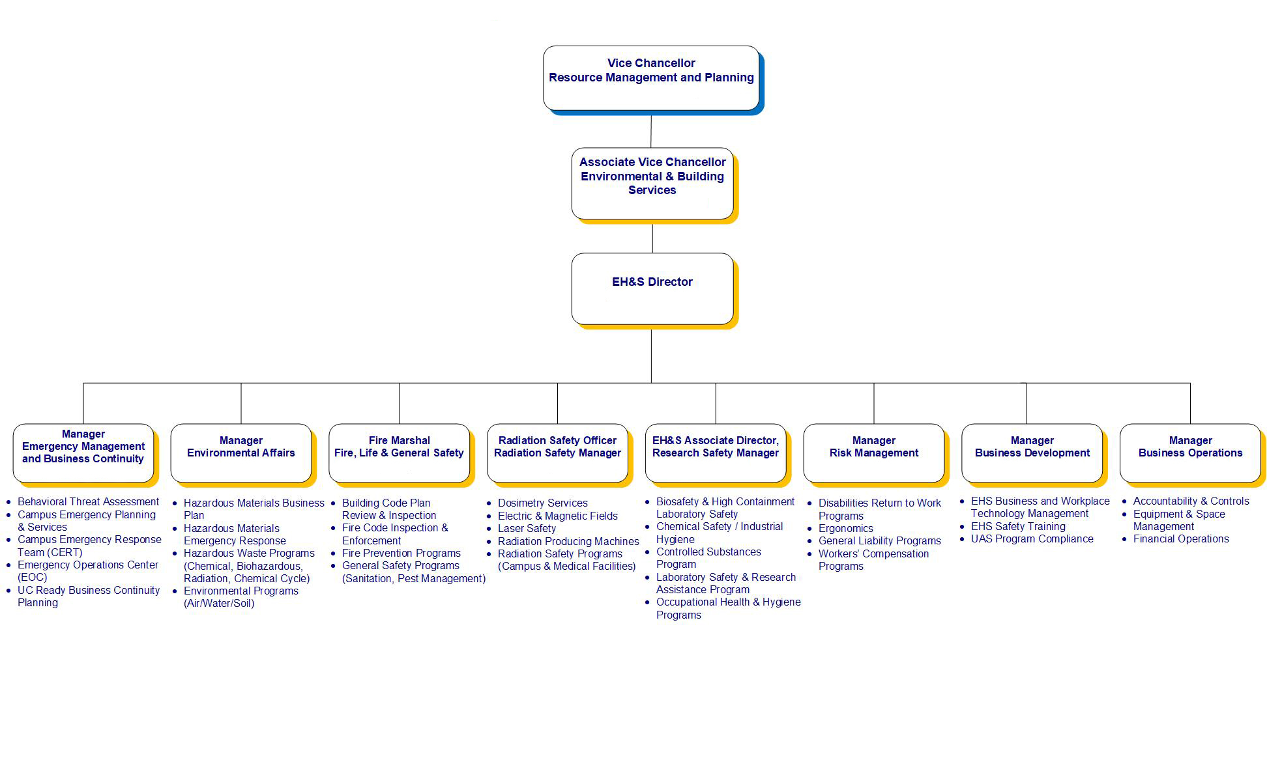

# Section3, Roles and responsibilities:

The roles and responsibilities of each one of the project's people should be well clarified; in order to assure the effectiveness of the globally accepted safety, health and environmental program as follows:

## 3.1: Senior Management:

Management's most essential role is to ensure a safe, hazard-free work space for all of the project's employees in the work place by the effective implementing of the S.H.E management system as follows:

* Provide the needed training for all of the employees in accordance with the S.H.E requirements.
* Assure the compliance with the accepted legal requirements.
* Provide the needed support and health training to the employees to carry out the S.H.E plan.
* Assign office spaces, computer equipment and support personal to the team as necessary to accomplish the work safely and on time.

## 3.2: Supervision Team:

Supervisors' main role is to assure, raise and make each worker fully aware of the hazards that may occur in the workplace, and to take the suitable action on the right time whenever a hazard takes place.

* Monitoring the competency of the company's employees to ensure a high quality for the work done on site.
* Guarantee an accepted level of knowledge by the workers to efficiently perform their duties.
* Maintain a copy of the recorded meetings each time it held on the site and provide it to the management.
* Investigation of any accident/incident that may occurs.

## 3.3: Employees:

all ore company's employees should have to ensure their legal responsibilities in accordance with our S.H.E plan to take the suitable action whenever their own safety requires that, and also to avoid the potential accident/incident as much as possible.

* Reporting hazards in the workplace.
* Work safely and follow safe work practice.
* Use all of the required personal protection equipment.
* Take part in every safety, health and environmental training programe established in the work place.

# Section4, Training and awareness:

## 4.1 Training

Employee safety training is another requirement of an effective injury and illness prevention program. While our company believes in skills training, we also want to emphasize safety training. All employees should start the safety training by reading this manual and discussing any problems or safety concerns with your direct supervisor. You may wish to make notes in the margins of this manual where it applies to your work.

## 4.2 Safety and Health Training

Training is one of the most important elements of any injury and illness prevention program. Such training is designed to enable employees to learn their jobs properly, bring new ideas to the workplace, reinforce existing safety policies and put the injury and illness prevention program into action. Training is required for both supervision and employees alike. The content of each training session will vary, but each session will attempt to teach the following:

a) the success of training program depends on the actions of individual employees as well as a commitment by the Company.

b) each employee's immediate supervisor will review the safe work procedures unique to that employee's job, and how these safe work procedures protect against risk and danger.

c) each employee will learn when personal protective equipment is required or necessary, and how to use and maintain the equipment in good condition.

d) each employee will learn what to do in case of emergencies occurring in the workplace.

Supervisors are also vested with special duties concerning the safety of employees. They have primary responsibility for actually implementing the injury and illness prevention program, especially as it relates directly to the workplace. Supervisors are responsible for being familiar with safety and health hazards to which employees are exposed, how to recognize them, the potential effects of these hazards, and rules and procedures for maintaining a safe workplace. Supervisors shall convey this information to the employees at the workplace, and shall investigate accidents according to the accident investigation policies contained in this manual.

## 4.3 Periodic Safety Training Meetings

our company has safety meetings every 3 months. The purpose of the meeting is to convey safety information and answer employee questions. The format of most meetings will be to review, in language understandable to every employee, the content of the injury prevention program, special work site hazards, serious concealed dangers, and material safety data sheets. Whenever a new practice or procedure is introduced into the workplace, it will be thoroughly reviewed for safety. A sign-up sheet will be passed around each meeting, and notes of the meeting will be distributed afterwards. A copy of the notes will also be placed in the file of each employee who attends the meeting. Employee attendance is mandatory and is compensable unless part of an official state approved training program or pre-employment requirement. Employee Responsibility for Training Teaching safety is a two-way street. Our company can preach safety, but only employees can practice safety. Safety education requires employee participation. Every 3 months, a meeting of all employees will be conducted for the purpose of safety instruction. The employees will discuss the application of the Company's S.H.E plan to actual job assignments. They will also read and discuss a section of the manual and review application of general safety rules to specific situations. Remember, the following general rules apply in all situations:

a) no employee should undertake a job that appears to be unsafe.

b) no employee is expected to undertake a job until he/she has received adequate safety instructions, and is authorized to perform the task.

c) no employee should use chemicals without fully understanding their toxic properties and without the knowledge required to work with these chemicals safely.

d) mechanical safeguards must be kept in place.

e) employees must report any unsafe conditions to the job site supervisor and the Responsible Safety Officer.

f) any work-related injury or illness must be reported to management at once.

g) personal protective equipment must be used when and where required. All such equipment must be properly maintained.